Final Project

Candidate Voting system

HArSimran Singh

|  |  |
| --- | --- |
| Client Name | Amritpal Singh |
| Email | Amritpal234@gmail.com |
| Phone | 2345432344 |

Table of Contents

Project Proposal 2

Project Introduction and Overview 2

Project Specifications 2

Project Goal 2

Scope 2

Project Specifications 2

Target Audience 3

Project Plan 3

Project Deliverables 3

Project Tasks and Milestones 3

Resources Required 4

Project Risks and Assumptions 4

Project Report 4

Aim and Introduction 4

Analysis 4

Functional and Non-Functional 4

Non-Functional 5

Design 6

Project Testing 11

System Usability Testing 12

Testing 12

User Manual 14

System Overview 14

System Summary 14

System Configuration 14

User Access Levels 14

# Project Proposal

# Project Introduction and Overview

This project is based on the Candidate Voting System. In this ASP.net project there are two types of account one for admin and other for the voter. Admin can add, edit, delete, and access details of the candidates. Admin can also edit, delete, and access details of voters. Moreover, admin can delete votes and view voting history. Voters can vote for candidates. Also, new voters can signup for the application. Voters can add, edit, delete, and access details of their accounts. Only registered admin can register new admins.

# Project Specifications

## Project Goal

The main goal of this project is to implement an online web application using Asp.Net. The name of this web application will be “Candidate Voting System” In this application there is admin and voters. Admin can manage candidates by adding, editing, deleting, and checking details. Also, admin can edit, delete, and check details for various voters. Moreover, voters can add, edit, delete, and check details for candidates. They can vote for candidates. Admin can register new admin and new voters can register.

## Scope

The main goal of this application is to implement a Candidate Voting System online application. This project is for 4 weeks.

# Project Specifications

* Secure login and registration for the candidates
* Secure login and admin registration for admins
* Admin can add, edit, delete candidates
* Admin can manage the votes and voting transactions.
* Admin can edit, delete, and access details of voters.
* Voter can add new candidates, edit, delete, and access for candidates.
* Voters can vote for other candidates.

## Target Audience

The main target audience for this project will the people who are willing to take part in voting. Age group should be 18 plus.

# Project Plan

## Project Deliverables

|  |  |
| --- | --- |
| **Deliverable** | **Description** |
| Project Planning | This document. Introduces the project and elaborates its details and requirements. |
| Project Coding | The application being made. Marking will be based on the GUI, functionality, implementation, and testing. |
| Implementation Details | This document elaborates on the projects details as well as its analysis, design, and implementation. |
| Final Documentation and Report | This includes the final documentation of the project. |

## Project Tasks and Milestones

|  |  |  |  |  |  |  |  |  |  |  |  |  |  |  |  |  |  |  |  |  |  |
| --- | --- | --- | --- | --- | --- | --- | --- | --- | --- | --- | --- | --- | --- | --- | --- | --- | --- | --- | --- | --- | --- |
| Project Stages | Major Activities | Week-1 | | | | Week-2 | | | | | Week-3 | | | | | | Week-4 | | | | |
| Planning | Technology Research |  |  |  |  | |  |  |  |  |  |  |  |  |  |  |  |  | |  |  |
| First Meeting |  |  |  |  | |  |  |  |  |  |  |  |  |  |  |  |  | |  |  |
| Project Proposal and Documentation |  |  |  |  | |  |  |  |  |  |  |  |  |  |  |  |  | |  |  |
| Phase -1 | Database Design |  |  |  |  | |  |  |  |  |  |  |  |  |  |  |  |  | |  |  |
| User Interface Design |  |  |  |  | |  |  |  |  |  |  |  |  |  |  |  |  | |  |  |
| Phase-2 | Identity framework implementation |  |  |  |  | |  |  |  |  |  |  |  |  |  |  |  |  | |  |  |
| Admin Implementation |  |  |  |  | |  |  |  |  |  |  |  |  |  |  |  |  | |  |  |
| Candidate Implementation |  |  |  |  | |  |  |  |  |  |  |  |  |  |  |  | |  |  |  |
| Testing |  |  |  |  | |  |  |  |  |  |  |  |  |  |  |  | |  |  |  |
| Final Phase | Final Documentation |  |  |  |  | |  |  |  |  |  |  |  |  |  |  |  | |  |  |  |

## Resources Required

* Microsoft office, excel
* Identity framework
* Asp.Net framework
* Windows Operating System 10 64-bit Processors
* 8 GB or more RAM.

## Project Risks and Assumptions

* Project can take more time than estimation
* It is not feasible to perform all types of testing.
* One admin and one candidate will be registered by default

# Project Report

## Aim and Introduction

The project aims to introduce a Candidate Voting System web application which will help voters to vote freely.

# Analysis

### Functional and Non-Functional

The functional requirements of this project are divided into types. One for Admin, and one for Voter.

|  |  |
| --- | --- |
| **Users** | **Functional Requirements** |
| **Admin** | * Login/logout * Register new admin * Manage candidates * Manage Voters * Delete votes * View Voting Transaction |
| **Candidate** | * Login/logout * New Candidates can register themselves. * Voter can add new candidates, edit, delete, and check details of the existing ones. * Voters can vote for candidates. |

### Non-Functional

|  |  |
| --- | --- |
| **Operational** | * The system should able to run on all web browsers and accessible via mobiles |
| **Security** | * Only Administrators have full access to the system. * Only Voters have access to their accounts and the right to vote for candidates. |

# Design

**Home Page**

This is the landing page of the web app. It consists- Home, vote, candidates, voter sign up, login, and register vote admin options on the navigation menu. 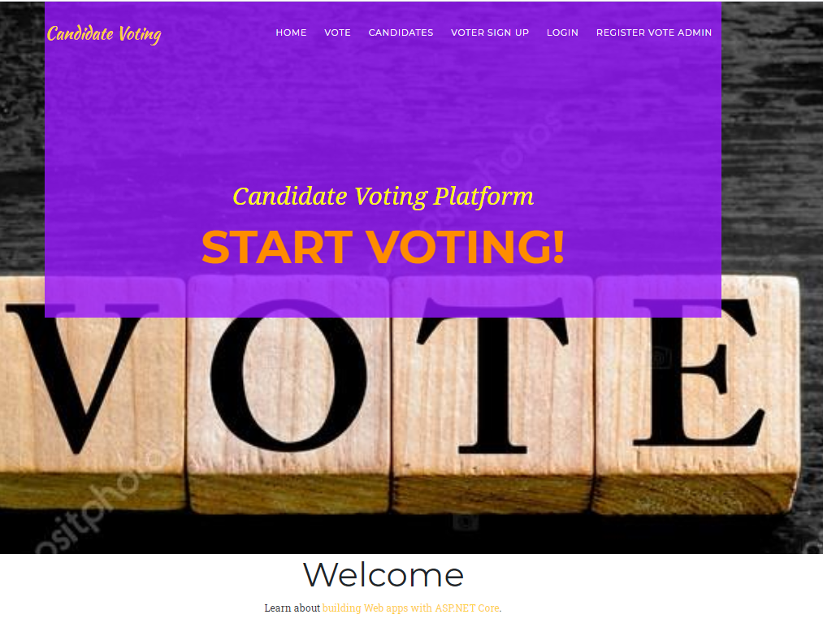

**Login Page**

This page helps the admin and voters to login to the app by using their valid credentials.

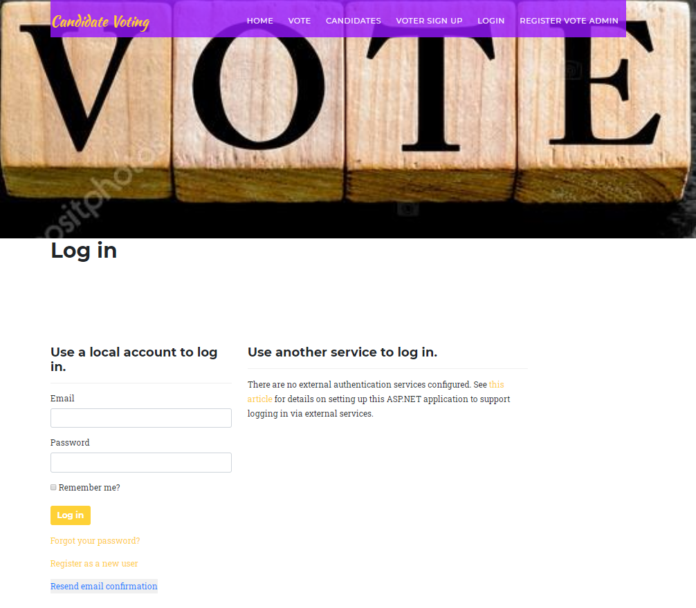

**Voter Signup Page**

With the help of this page new voters can signup for the application.

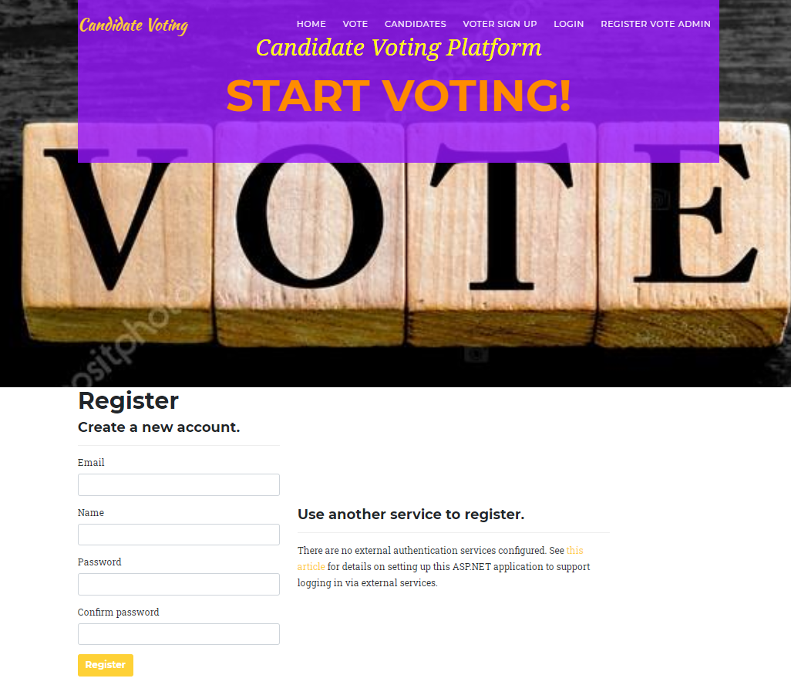

**Admin Registration Page**

With the help of this page admin can register new admin for the application.

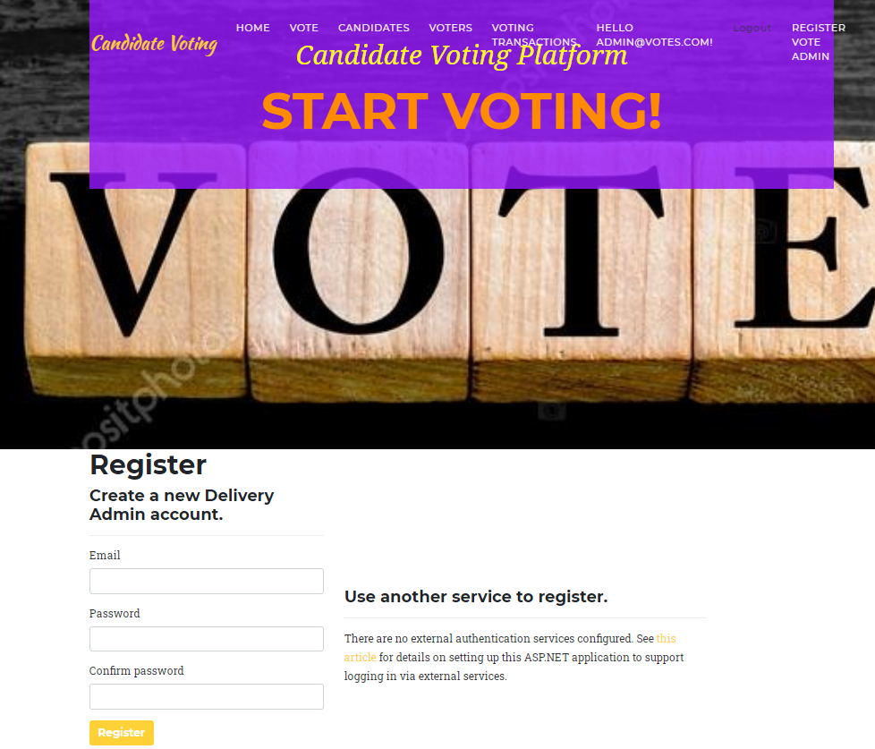

**Candidate Page Admin View**

With the help of this page admin can add new candidates and manage existing ones.

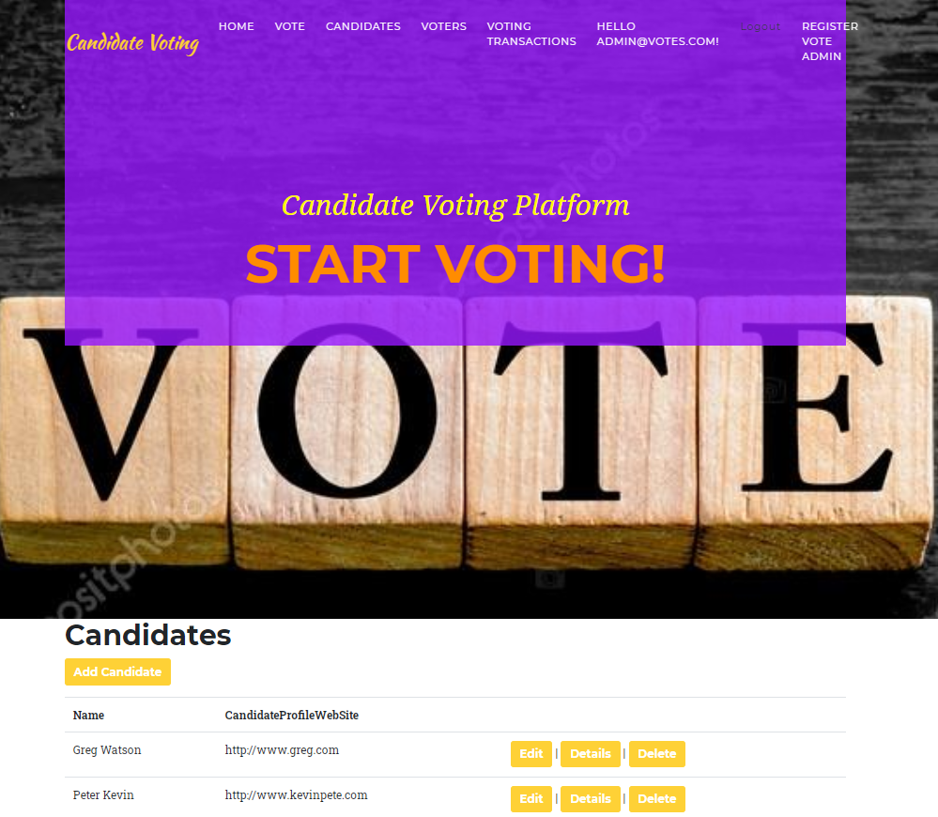

**Voters Page Admin View**

This Page highlights voters. Admin can edit, delete, and access their details.

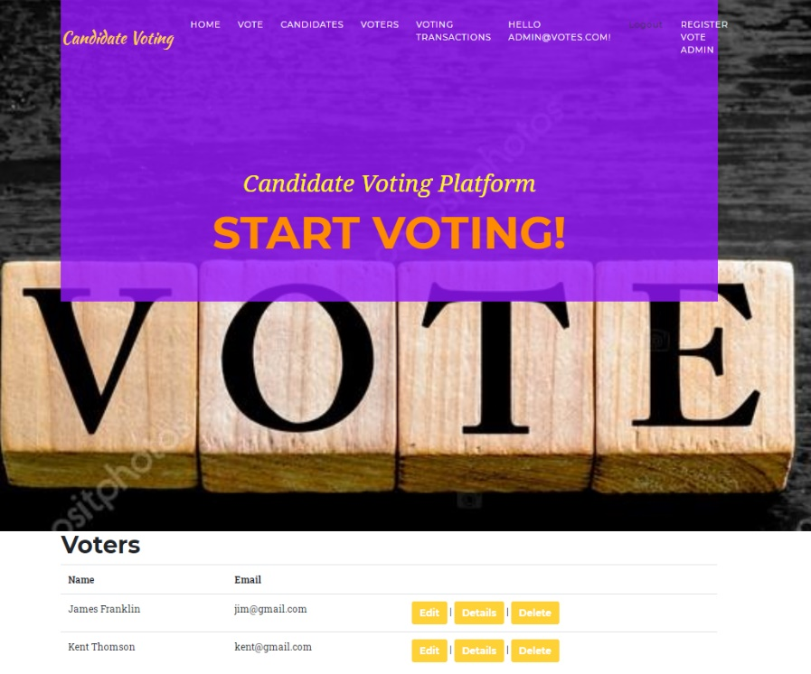

**Vote Page Admin View**

With this page admin can delete all votes.

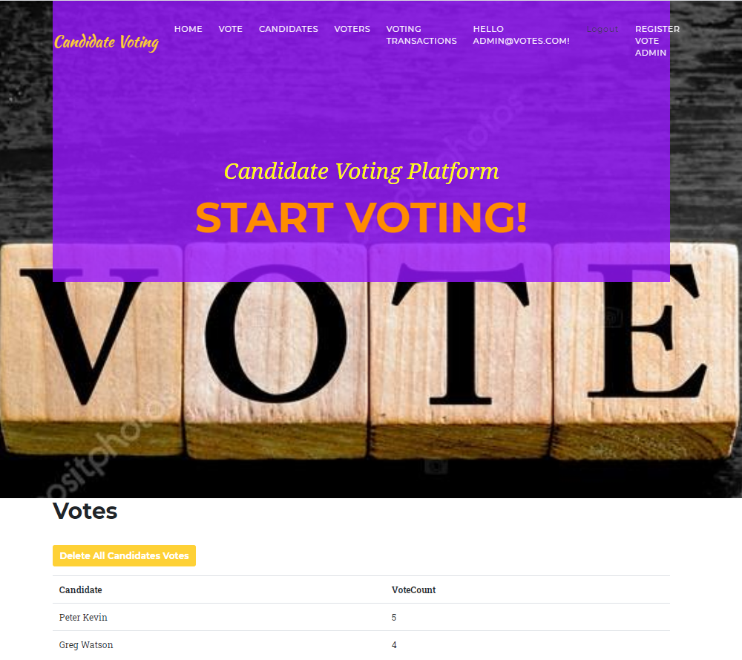

**Voting Transaction Page**

This page highlights the details of candidates and voters in the form of voting transactions.

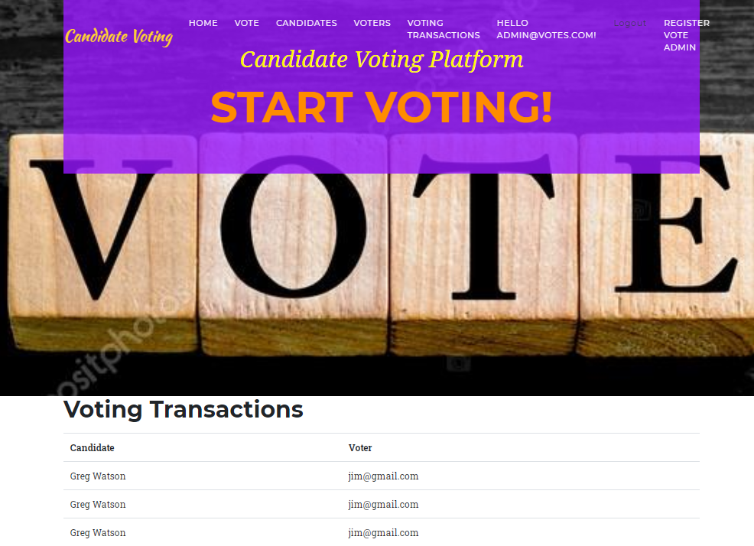

**Votes Page Voter View**

With the help of this page voters can vote for candidates.

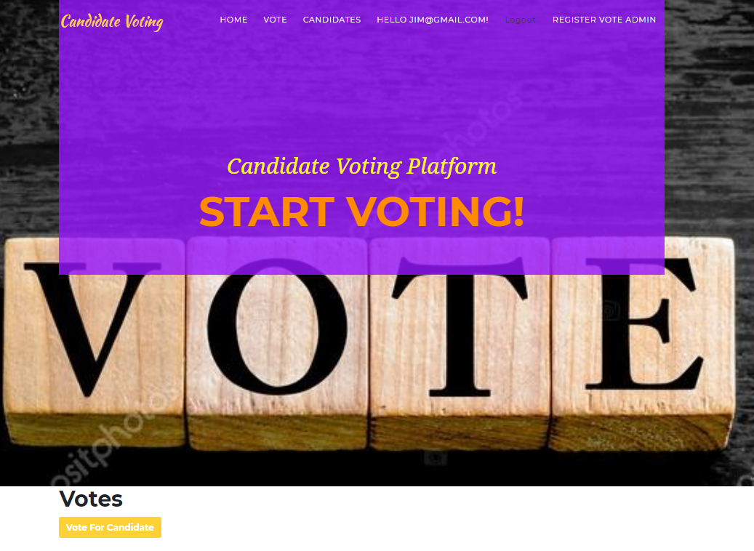

**Candidate Page Voter View**

With the help of this page voters can add new candidates and manage existing ones.

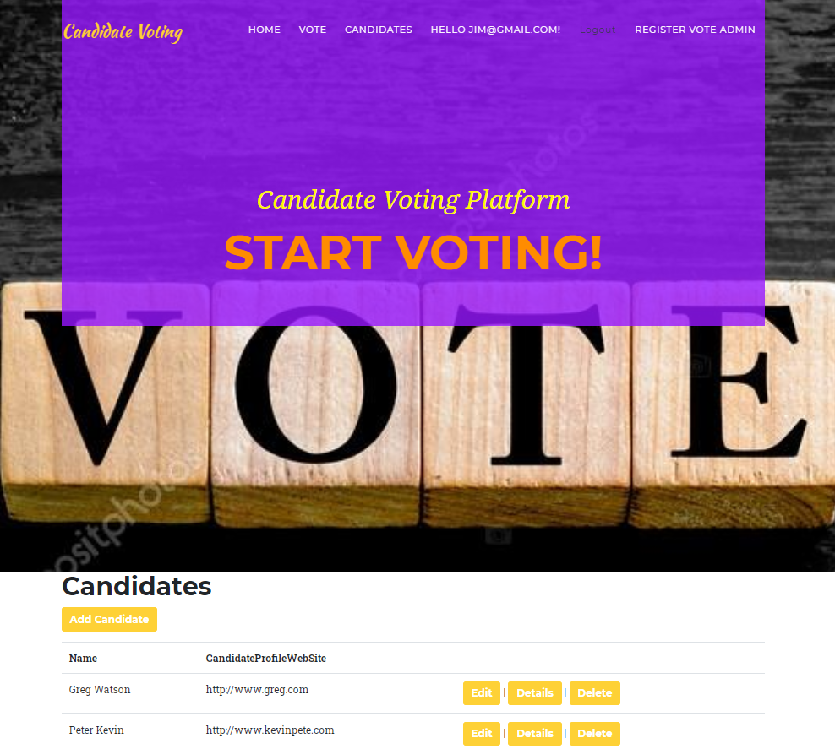

|  |  |  |  |  |  |
| --- | --- | --- | --- | --- | --- |
| **Test Case ID** | | TC1 | | | |
| **Test Case Title** | | verify the launching of web app | | | |
| **Pre-Conditions** | | Browser the web app | | | |
| **Post-Conditions** | | Website should be launched successfully | | | |
| **Step No.** | **Test Step** | **Input Data** | **Expected Result** | **Actual Result** | **Test Step Result** |
| 1 | open [project](http://www.authordeus.azurewebsites.com) in Visual studio |  | website index page should open | As Expected | Pass |
| 2 | Close the Home page by clicking close button on browser |  | Website should close. | As Expected | Pass |
| 3 | Manually Launched website using localhost |  | website home page should open | As Expected | Pass |

# Project Testing

**Test Case 1**

**Test Case 2**

|  |  |  |  |  |  |
| --- | --- | --- | --- | --- | --- |
| **Test Case ID** | | TC2 | | | |
| **Test Case Title** | | Verify login with valid username and password | | | |
| **Pre-Conditions** | | username and password are saved into the database | | | |
| **Post-Conditions** | | The user is validated with database and successfully login to the account. | | | |
| **Step No.** | **Test Step** | **Input Data** | **Expected Result** | **Actual Result** | **Test Step Result** |
| 1 | Launch web app in a new browser window |  | Login screen of the website should display. | As Expected | Pass |
| 2 | Enter valid User id and correct password | User: admin@votes.com  Password: 1qaz2wsX@ | Entered User Id should display in "User Id" field  Enter Password should be masked as "*" | As Expected | Pass |
| 3 | Click the "Login" button |  | The home page should open and the user id should display at the top right side on the page. | As Expected | Pass |
| 4 | Enter valid User Id and incorrect Password | User: admin@votes.com  Password: 1qaz2wsX | Error Message should appear for an incorrect password. | As Expected | Pass |
| 5 | Enter Invalid User Id and correct password | User: ad@votes.com  Password: 1qaz2wsX@ | Error Message should appear for the incorrect User ID. | As Expected | Pass |
| 6 | Enter Invalid User Id and incorrect password | User: jim@vote.com  Password: 1qa | Error Message should appear for incorrect User ID and password | As Expected | Pass |

**Test Case 3**

|  |  |  |  |  |  |
| --- | --- | --- | --- | --- | --- |
| **Test Case ID** | | TC3 | | | |
| **Priority** | | High | | | |
| **Test Case Title** | | Verify website Home Page interface | | | |
| **Pre-Conditions** | | Open website in a browser | | | |
| **Post-Conditions** | | The home page interface should correct and working correctly. | | | |
| **Step No.** | **Test Step** | **Input Data** | **Expected Result** | **Actual Result** | **Test Step Result** |
| 1 | Verify Home Page |  | should display all options | As Expected | Pass |
| 2 | Verify navigation bar |  | Following options should be available in the navigation bar   * Home * vote * Candidates * Voter Sign up * Login * Register Vote Admin | As expected | Pass |

## System Usability Testing

### Testing

**Tester 1**

|  |  |  |  |  |  |  |
| --- | --- | --- | --- | --- | --- | --- |
| **Tester –1** | | **Answer Scale** | | | | |
| **No.** | **Question** | **Strongly Disagree (1)** | **Disagree (2)** | **Normal (3)** | **Agree (4)** | **Strongly Agree (5)** |
| 1 | I think that I would like to use this system frequently |  |  |  |  |  |
| 2 | I found the system complex |  |  |  |  |  |
| 3 | I thought the system was easy to use |  |  |  |  |  |
| 4 | I found the various functions in this system were well-integrated |  |  |  |  |  |
| 5 | I thought there was too much inconsistency in this system |  |  |  |  |  |
| 6 | I would imagine that most people would learn to use this system very quickly |  |  |  |  |  |
| 7 | I felt very confident using the system |  |  |  |  |  |

**Tester-2**

|  |  |  |  |  |  |  |
| --- | --- | --- | --- | --- | --- | --- |
| **Tester –2** | | **Answer Scale** | | | | |
| **No.** | **Question** | **Strongly Disagree (1)** | **Disagree (2)** | **Normal (3)** | **Agree (4)** | **Strongly Agree (5)** |
| 1 | I think that I would like to use this system frequently |  |  |  |  |  |
| 2 | I found the system complex |  |  |  |  |  |
| 3 | I thought the system was easy to use |  |  |  |  |  |
| 4 | I found the various functions in this system were well-integrated |  |  |  |  |  |
| 5 | I thought there was too much inconsistency in this system |  |  |  |  |  |
| 6 | I would imagine that most people would learn to use this system very quickly |  |  |  |  |  |
| 7 | I felt very confident using the system |  |  |  |  |  |

# User Manual

### System Overview

Candidate Voting System, In this ASP.net project there are two types of account one for admin and other for the voter. Admin can add, edit, delete, and access details of the candidates. Admin can also edit, delete, and access details of voters. Moreover, admin can delete votes and view voting history. Voters can vote for candidates. Also, new voters can sign up for the application. Voters can add, edit, delete, and access details of their accounts. Only registered admin can register new admins.

## System Summary

### System Configuration

Candidate Voting System is a web application developed using Microsoft Visual Studio 2019. It will run on most modern web browsers and will not require any special system configuration.

### User Access Levels

Only registered users can access the features of the app. Also, this app has different types of users; each with different access to the web application’s features.

* **System Admin:** Full access to the system and all functionalities. Full access to all stored data.
* **Voter:** Access to limited services.